Group10-PA1 Potential Solutions
FIFA.com and Chess.com web experiences
Đồ án PA1 - Môn Thiết kế giao diện - 23KTPM2
Team members
Member | Student ID | Main ownership
Le Minh | 21127645 | FIFA.com drawbacks, source trail, final QA
Nguyen Vu Bach | 21127224 | FIFA.com navigation, match-centre solutions, review
Pham Nguyen Gia Bao | 20127119 | Chess.com play, premove, solution mapping
Trang Minh Nhut | 22127318 | Chess.com learning, analysis, document review
Summary
The solution set keeps FIFA.com focused on task-first navigation, continuity across FIFA+, clearer ticket status, and utility entry points. It keeps Chess.com focused on novice onboarding, simpler analysis, expectation-setting around access limits, safer premoves, and clearer Focus Mode discovery.
Revision approach
This Word version reorganizes the original long tables into per-drawback solution cards. Each card keeps the problem, persona, context, HCI cause, proposed UI change, expected improvement, tradeoff, priority, and effort together on the same page. Solution visuals are labeled as low-fidelity UI proposals, not captured live UI.
Traceability and drawback inventory
Relationship to ProductResearch findings

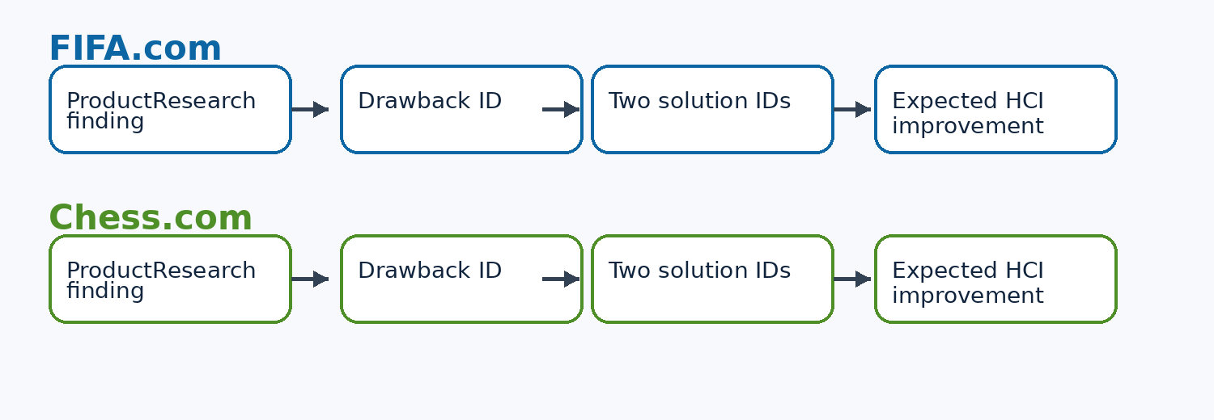
Each drawback maps to its ProductResearch finding, evidence source, affected persona/context, and exactly two solution IDs.
ID | Product |  | Drawback | Linked finding | Severity |  | Solution IDs
F-D1 | FIFA.com |  | Cross-property navigation and top-level task competition span FIFA. | F-HCI6 | High |  | F-S1, F-S2
F-D2 | FIFA.com |  | The DAZN-branded FIFA+ handoff changes brand and account expectations, creating trust friction and mode-boundary confusion. | F-HCI7 | High |  | F-S3, F-S4
F-D3 | FIFA.com |  | Dense FIFA+ watch rails increase the scan load for live, highlight, documentary, competition, and archive content. | F-HCI8 | Medium |  | F-S5, F-S6
F-D4 | FIFA.com |  | Sale, resale, waiting-room, and availability uncertainty force repeated manual checks. | F-HCI9 | High |  | F-S7, F-S8
F-D5 | FIFA.com |  | Article-to-score, article-to-ticket, and article-to-watch tasks require extra navigation after reading. | F-HCI10 | Medium |  | F-S9, F-S10
C-D1 | Chess.com |  | The broad menu and feature taxonomy overload novices before they know which path fits their goal. | C-HCI7 | High |  | C-S1, C-S2
C-D2 | Chess.com |  | Game Review and Analysis expose dense charts, lines, classifications, toggles, and labels before novices know what matters. | C-HCI10 | High |  | C-S3, C-S4
C-D3 | Chess.com |  | Lesson, puzzle, and review limits can appear after attention is invested and interrupt learning momentum. | C-HCI10 | Medium |  | C-S5, C-S6
C-D4 | Chess.com |  | A legal queued premove may execute after an unexpected reply and create a blunder. | C-HCI8 | High |  | C-S7, C-S8
C-D5 | Chess.com |  | Focus Mode is hard to discover because related controls appear on hover near the board boundary. | C-HCI9 | Medium |  | C-S9, C-S10
FIFA.com solution set
Focus area |  | Problem class |  | Main solution direction |  | Why it matters
Navigation |  | Ecosystem sprawl |  | Task-first navigation and intent chips |  | Fewer property jumps for fans who need scores, news, rankings, tickets, or watch actions.
FIFA+ handoff |  | Brand and account boundary |  | Handoff explainer and shared breadcrumb |  | Clearer destination expectations and return path.
Ticketing |  | Unclear sale/resale/waiting status |  | Ticket status dashboard and official alerts |  | Better planning support for trust-sensitive family ticket decisions.
Articles |  | Browse-first friction |  | Utility rail and embedded action chips |  | Readers can move from story context to scores, tickets, or watch actions.

F-D1 - FIFA.com drawback and solution card
Problem  Cross-property navigation and top-level task competition span FIFA.com, Inside FIFA, FIFA+, Store, Collect, and Rewards. |  | Persona  F-P1 / F-P3 |  | Context  Short task entry and trust-sensitive planning. |  | HCI cause  Context switching; mental-model consistency.
Evidence  F-09B + [1][6][9] |  | Severity  High |  | Priority  High |  | Effort  Medium
Observed evidence or source status |  |  |  | Low-fidelity UI proposal
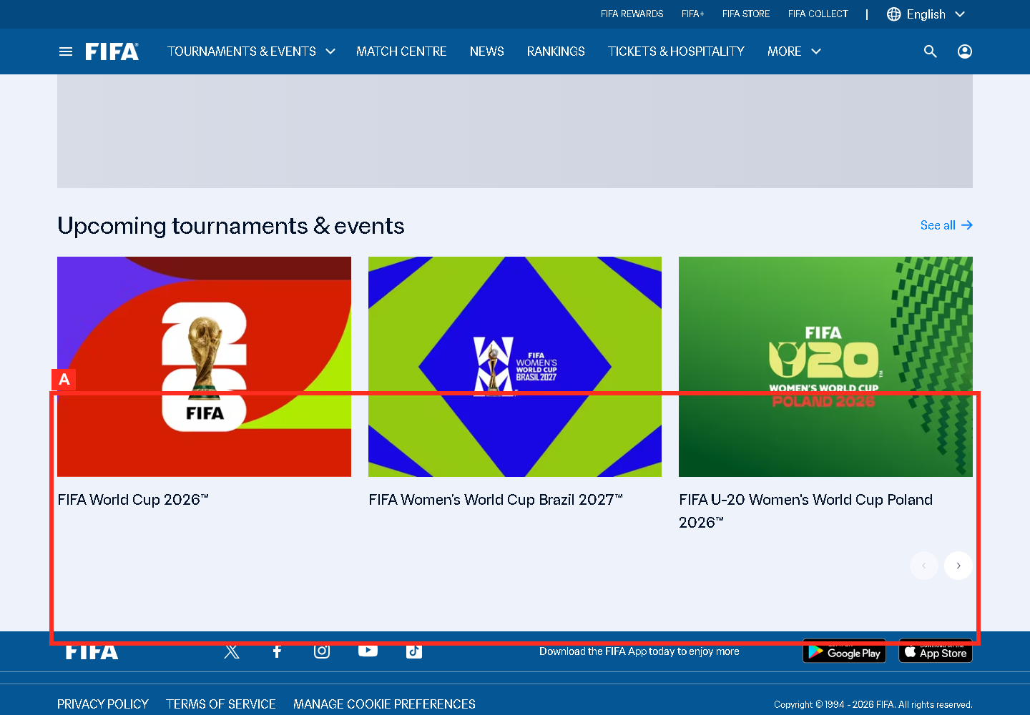  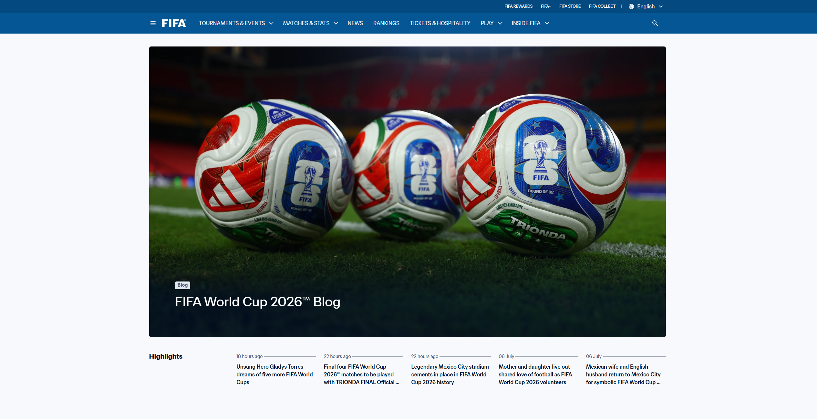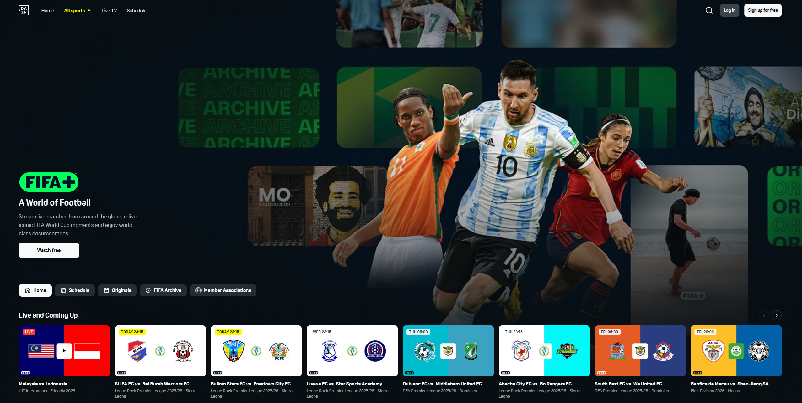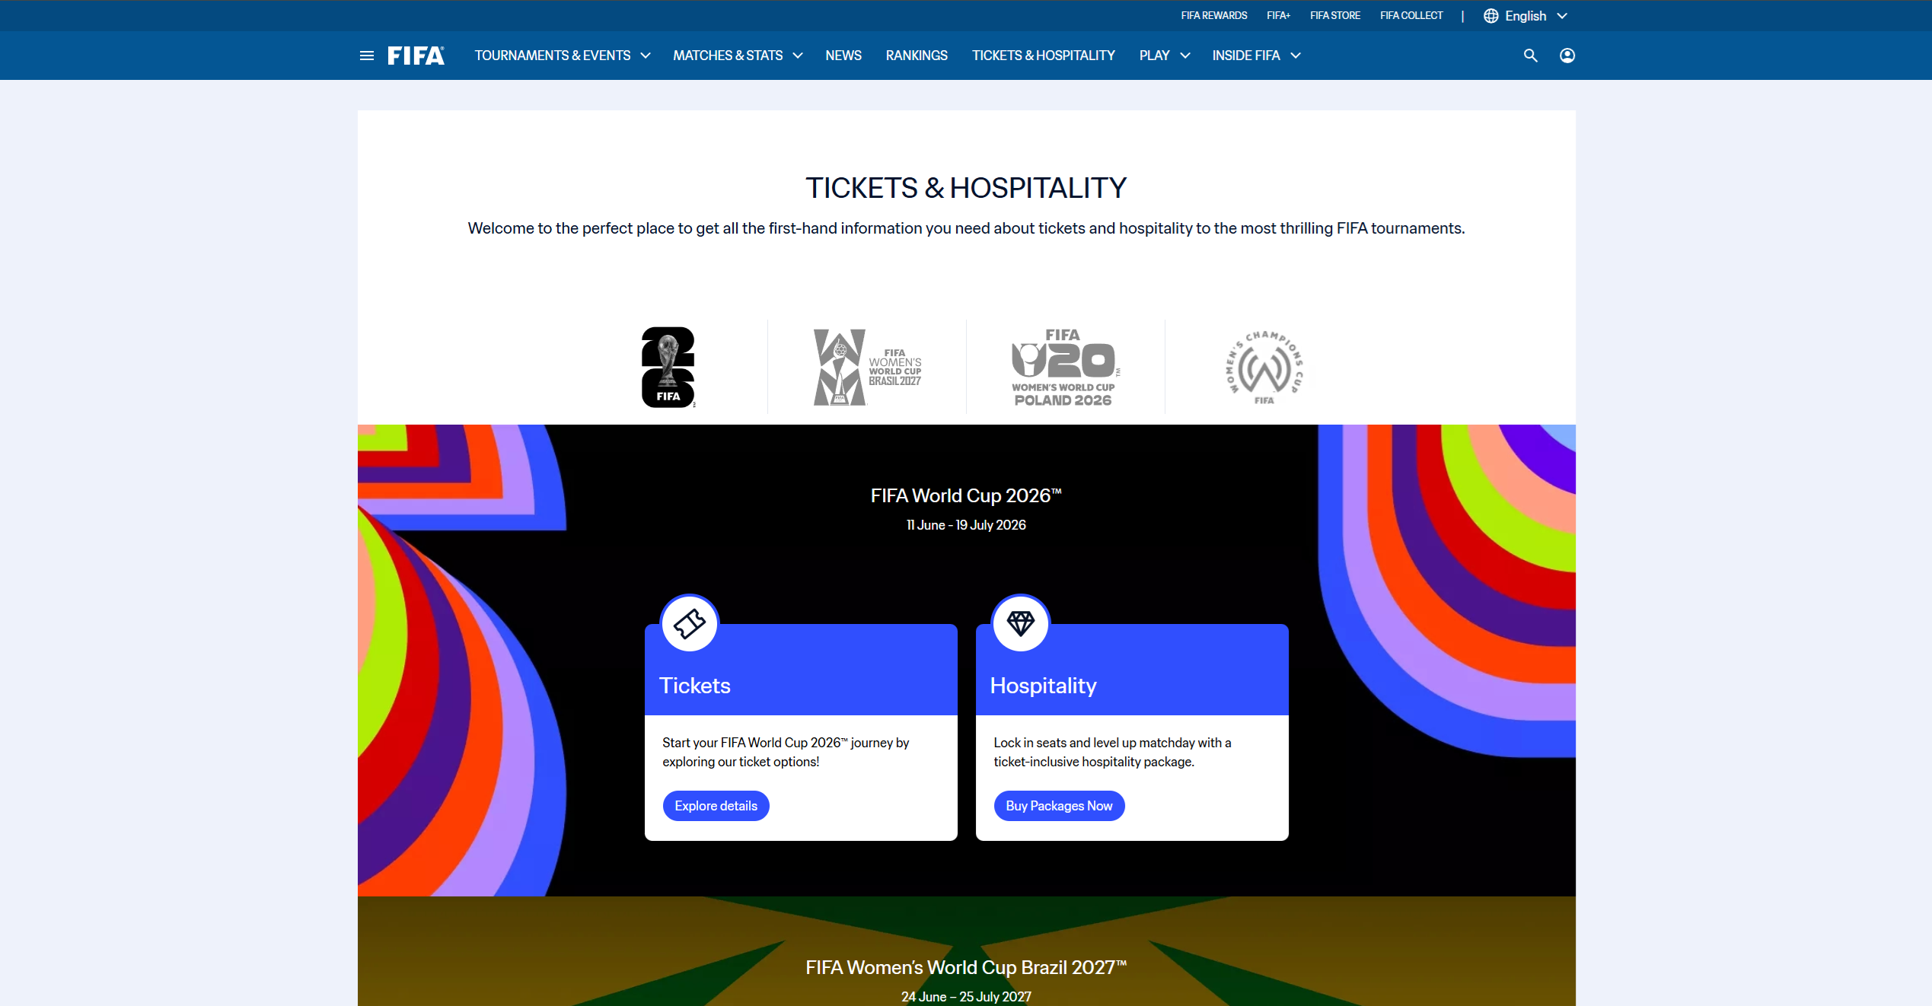  Evidence: F-09B_fifa_footer_ecosystem.png (F-09B + [1][6][9]) |  |  |  | Change the following UI locations:  - Global header: keep Match Centre, News, Rankings, Tickets, and Watch visible as the five primary task destinations (F-S1).  - Header overflow: move Store, Collect, Rewards, and other corporate properties into a clearly labelled More FIFA menu.  - Directly below the homepage hero: add intent chips for Scores, News, Rankings, Tickets, and Watch (F-S2).  Cross-property links: show destination brand and a Back to FIFA.com path before users leave the current property.
ID | Solution concept |  | How the UI fixes it | HCI principle | Expected result |  | Tradeoff
F-S1 | Task-first global nav |  | Keep Match Centre, News, Rankings, Tickets, Watch at top level; move Store, Collect, and Rewards into More FIFA. | Recognition over recall; Cognitive load reduction. | Fewer property jumps for common tasks. |  | Store and collectibles receive less top-level exposure.
F-S2 | Audience intent switcher |  | Add five quick-intent chips under the hero: Scores, News, Rankings, Tickets, Watch. | Feedforward; efficient entry. | Users choose by intent before reading navigation labels. |  | One more row competes for above-fold attention.

F-D2 - FIFA.com drawback and solution card
Problem  The DAZN-branded FIFA+ handoff changes brand and account expectations, creating trust friction and mode-boundary confusion. |  | Persona  F-P3 |  | Context  Family watch handoff after ticket or news research. |  | HCI cause  Continuity; orientation; visibility of system status.
Evidence  Source-only [6] |  | Severity  High |  | Priority  High |  | Effort  Medium
Observed evidence or source status |  |  |  | Low-fidelity UI proposal
  Evidence: F-10B_fifa_plus_media.png (Source-only [6]) |  |  |  | Change the following UI locations:  - Before the FIFA+ outbound action: insert an explainer card stating that FIFA+ is powered by DAZN and whether sign-in is required (F-S3).  - FIFA+ top bar: add a persistent Back to FIFA.com control and retain FIFA visual identity during the handoff (F-S4).  - Primary CTA area: state what opens next—live stream, replay, or sign-in—before navigation occurs.  Account boundary: distinguish FIFA.com and DAZN account state with explicit labels instead of relying on branding alone.
ID | Solution concept |  | How the UI fixes it | HCI principle | Expected result |  | Tradeoff
F-S3 | Handoff explainer card |  | Before leaving FIFA.com, show You are opening FIFA+ powered by DAZN with destination benefits and sign-in expectation. | Visibility of system status; trust. | Users understand why branding and login state change. |  | Adds one step for repeat viewers.
F-S4 | Shared breadcrumb and visual bridge |  | Add persistent Back to FIFA.com strip and tournament breadcrumb on FIFA+. | Continuity; orientation. | Users retain orientation across the watch boundary. |  | Needs cross-property coordination.

F-D3 - FIFA.com drawback and solution card
Problem  Dense FIFA+ watch rails increase the scan load for live, highlight, documentary, competition, and archive content. |  | Persona  F-P3 |  | Context  Evening highlight search with family waiting. |  | HCI cause  Visual attention; choice overload; Progressive disclosure.
Evidence  [6] |  | Severity  Medium |  | Priority  Medium |  | Effort  Medium
Observed evidence or source status |  |  |  | Low-fidelity UI proposal
  Evidence: (6) |  |  |  | Change the following UI locations:  - Above the first media rail: add filters for Live, Highlights, Documentaries, Competitions, and Archive (F-S5).  - Each rail header: show item count and a concise See all action so users can predict the content scope.  - Media results area: add Compact scan mode with smaller cards and metadata-first rows (F-S6).  Nonmatching rails: collapse them to labelled summaries after a filter is selected, with an option to restore all content.
ID | Solution concept |  | How the UI fixes it | HCI principle | Expected result |  | Tradeoff
F-S5 | Filter-first rail controls |  | Provide filters for Live, Highlights, Documentaries, Competition, and Duration above rails. | Visual filtering; reduced scan cost. | Users narrow a large content surface faster. |  | Filter accuracy depends on metadata quality.
F-S6 | Compact scan mode |  | Collapse nonmatching rails into section labels until expanded. | Progressive disclosure; visual economy. | Lower vertical scanning burden. |  | Some content feels less discoverable.

F-D4 - FIFA.com drawback and solution card
Problem  Sale, resale, waiting-room, and availability uncertainty force repeated manual checks. |  | Persona  F-P3 |  | Context  Multi-day family travel and ticket planning. |  | HCI cause  Visibility of system status; prospective memory.
Evidence  Source-only [5][9] |  | Severity  High |  | Priority  High |  | Effort  Medium
Observed evidence or source status |  |  |  | Low-fidelity UI proposal
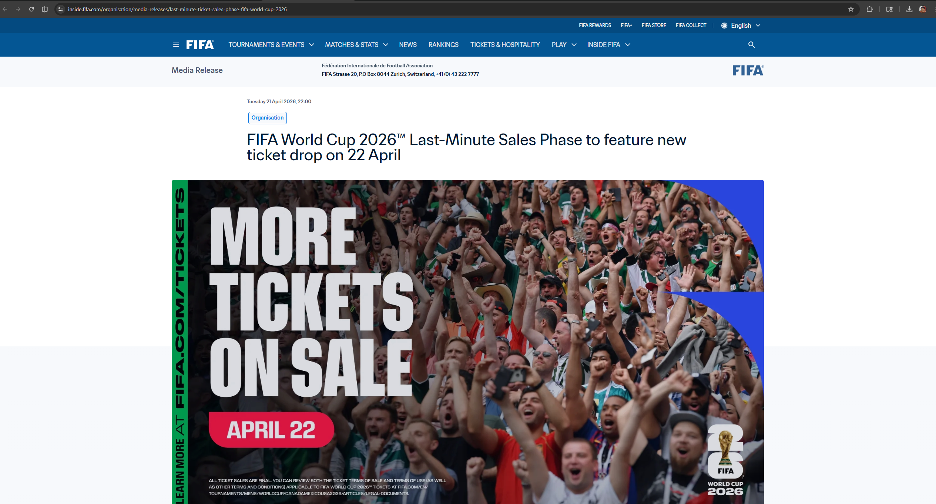   |  |  |  | Change the following UI locations:  - Tickets landing page, above tournament cards: add a status dashboard for Official sale, Resale, Waiting room, and Sold out (F-S7).  - Every ticket card: display last-updated time, next known milestone, and one official action button.  - Beside each tournament status: add opt-in email/browser availability alerts by date and team (F-S8).  Waiting-room and unavailable states: preserve the selected tournament and explain whether users should act now or return later.
ID | Solution concept |  | How the UI fixes it | HCI principle | Expected result |  | Tradeoff
F-S7 | Ticket status dashboard |  | Show Official sale, Resale open, Waiting room, Coming soon, and Latest update time by tournament. | Visibility of system status; planning support. | Users know whether to act now or wait. |  | Requires reliable status data and governance.
F-S8 | Official availability alerts |  | Offer email and browser alerts by tournament and market, confirmed by receipt. | Memory load reduction; trust. | Users stop manually rechecking availability. |  | Notification fatigue and opt-in compliance.

F-D5 - FIFA.com drawback and solution card
Problem  Article-to-score, article-to-ticket, and article-to-watch tasks require extra navigation after reading. |  | Persona  F-P1 / F-P2 / F-P3 |  | Context  Interrupted story reading followed by a utility task. |  | HCI cause  Task continuity; efficiency; information scent.
Evidence  F-06 + [1][2][3][7] |  | Severity  Medium |  | Priority  Medium |  | Effort  Low
Observed evidence or source status |  |  |  | Low-fidelity UI proposal
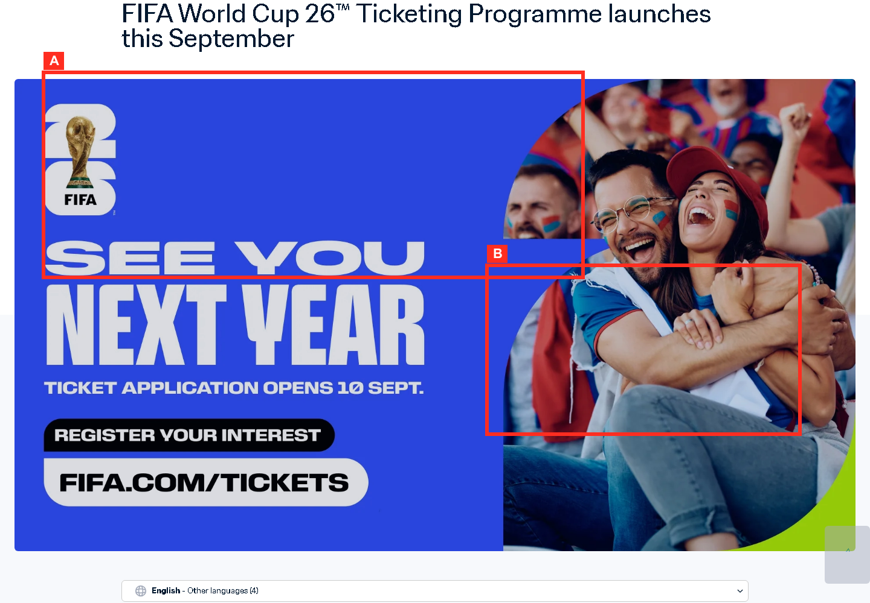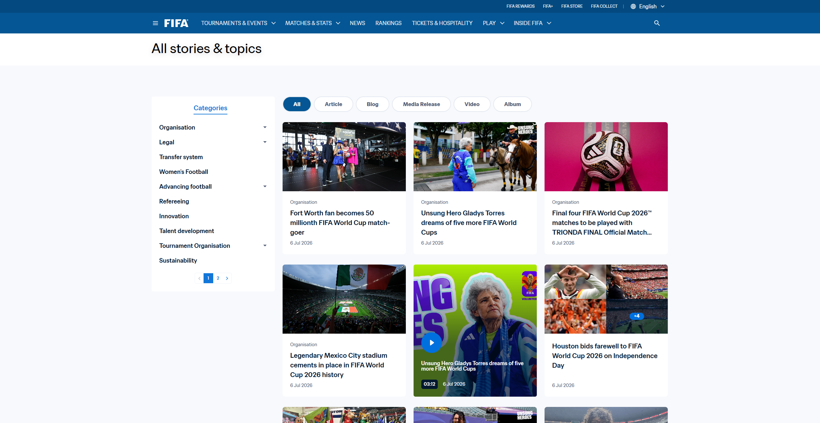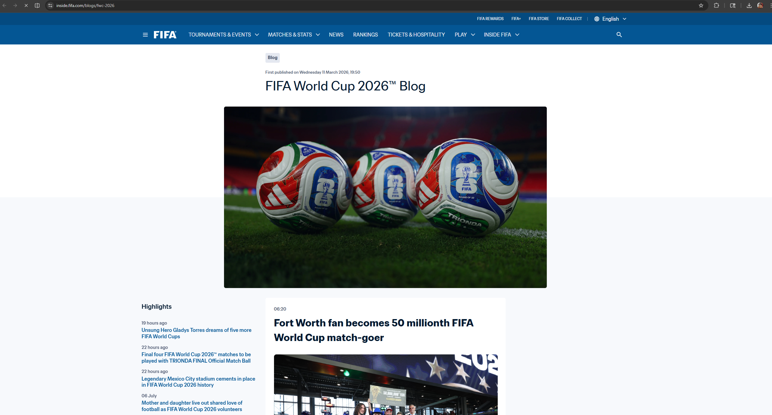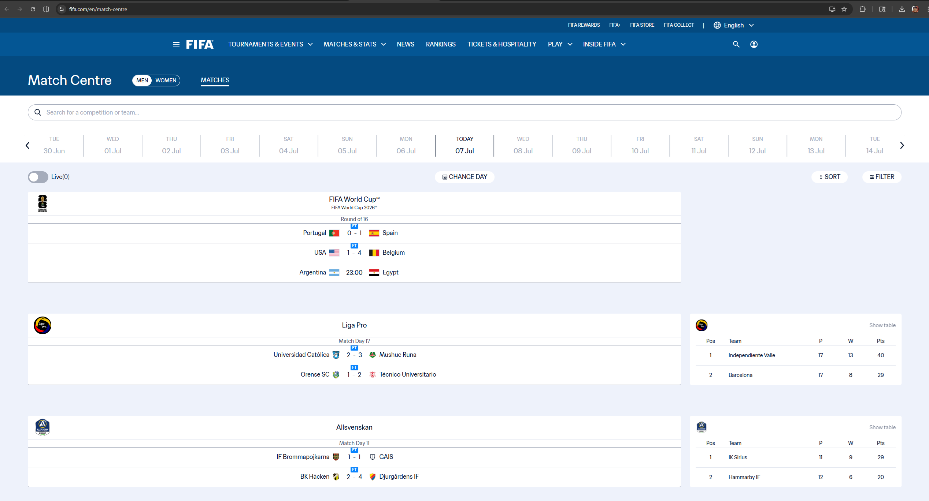  Evidence: F-06_fifa_news_article.png (F-06 + [1][2][3][7]) |  |  |  | Change the following UI locations:  - Article desktop layout: add a sticky utility rail for Scores, Tickets, Watch, and related tournament information (F-S9).  - Article header, below title metadata: add context chips such as Open Match Centre, Ticket status, and Watch highlights (F-S10).  - On mobile: convert the utility rail into a bottom sheet that does not cover the article text.  Action labels: derive the linked competition/team from article metadata so links remain contextual rather than generic.
ID | Solution concept |  | How the UI fixes it | HCI principle | Expected result |  | Tradeoff
F-S9 | Utility rail on story pages |  | Add right rail or sticky side sheet for Scores today, Rankings latest, Tickets official source, Watch now. | Task continuity; reduced jumping. | Story readers can branch into utilitarian tasks in context. |  | May distract from article reading.
F-S10 | Embedded action chips in articles |  | Add context chips in article header: Open Match Centre, View Tickets, Watch on FIFA+. | Contextual navigation; information scent. | Users can act from the article without searching navigation again. |  | Requires article metadata rules.

Chess.com solution set
Focus area | Problem class | Main solution direction | Why it matters
Onboarding | Feature overload for novices | Goal-based onboarding and personal dashboard | Beginner users see goals before product taxonomy.
Analysis | High Cognitive load | Beginner analysis preset and inline glossary | Game Review becomes readable before expert controls appear.
Learning access | Premium gates interrupt momentum | Upfront entitlement labels and soft landing | Users know access limits before investing attention.
Fast play | Premove risk and hidden Focus Mode | Queue preview, clear shortcut, coachmark, settings shortcut | Better Error prevention, recovery, and discoverability.

C-D1 - Chess.com drawback and solution card
Problem  The broad menu and feature taxonomy overload novices before they know which path fits their goal. |  | Persona  C-P1 |  | Context  First visit and beginner study. |  | HCI cause  Choice overload; Progressive disclosure.
Evidence  C-06 + [10][18][19][20] |  | Severity  High |  | Priority  High |  | Effort  Medium
Observed evidence or source status |  |  |  | Low-fidelity UI proposal
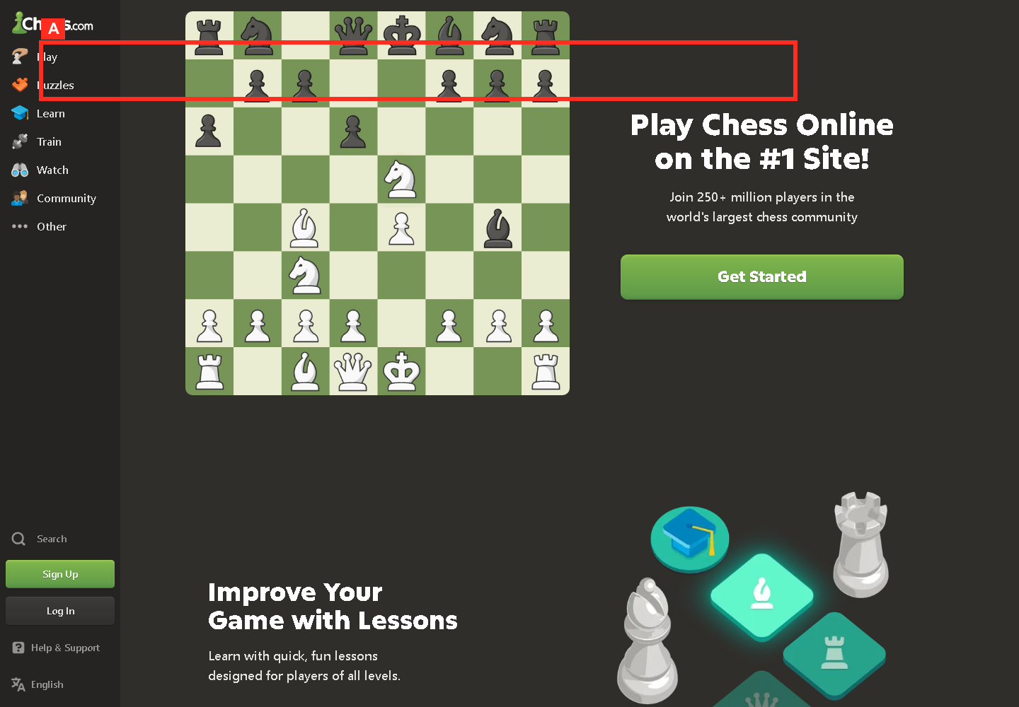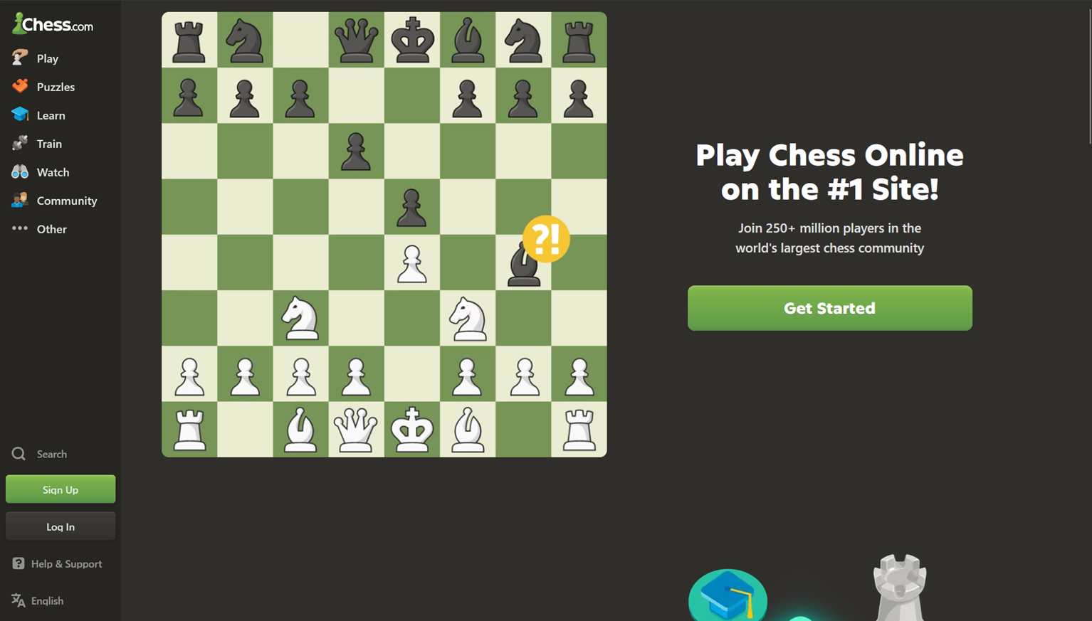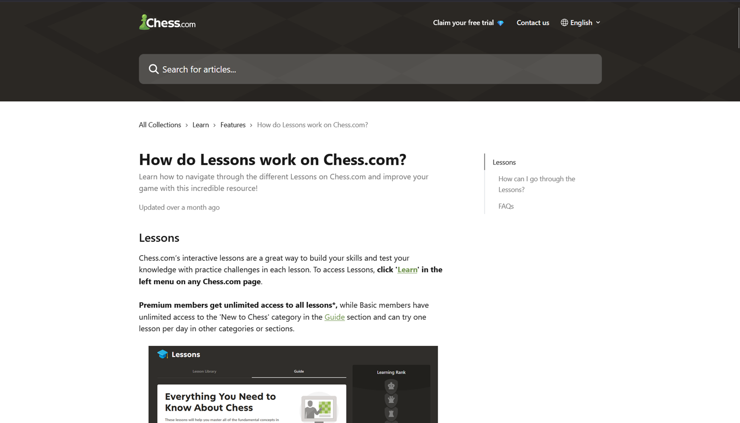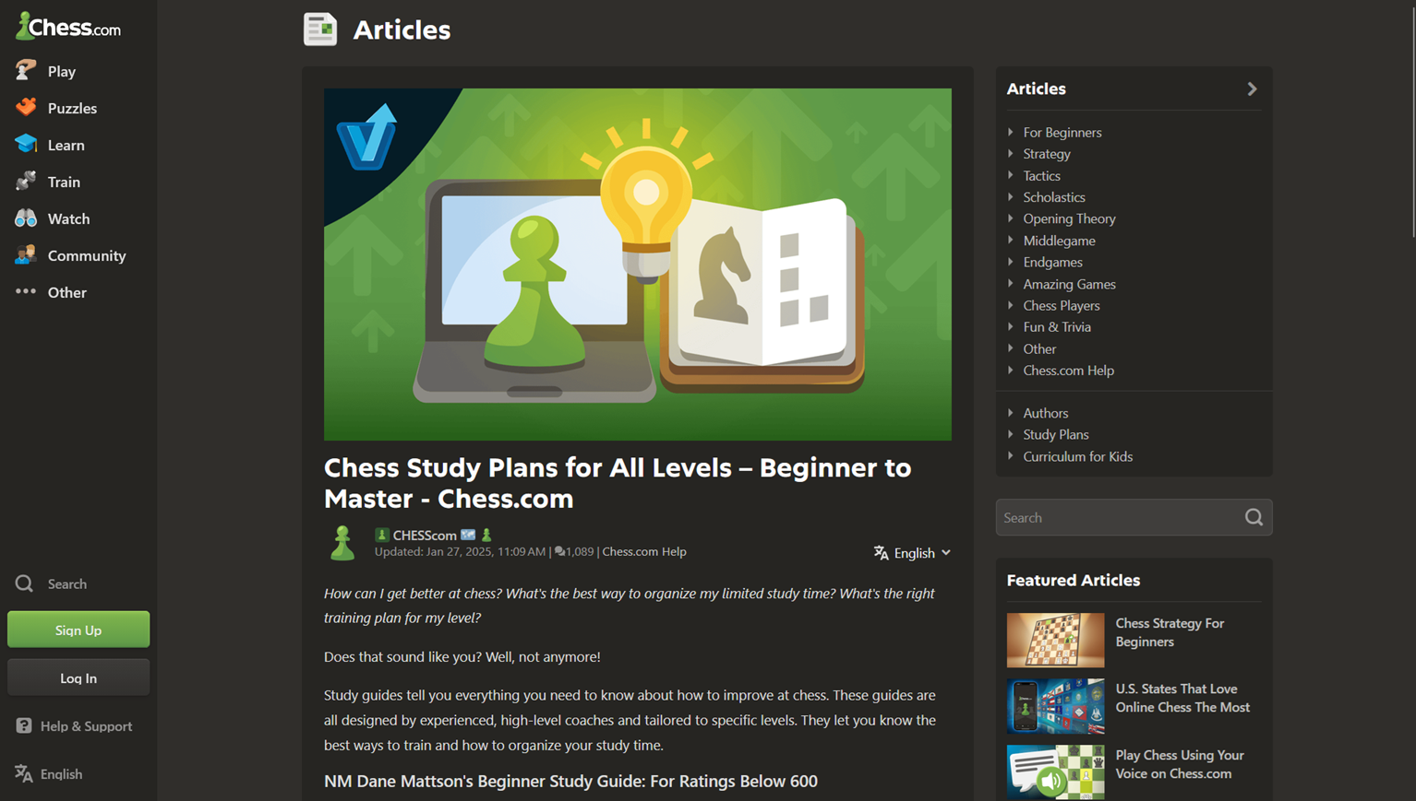  Evidence: C-06_chess_navigation_menu.png (C-06 + [10][18][19][20]) |  |  |  | 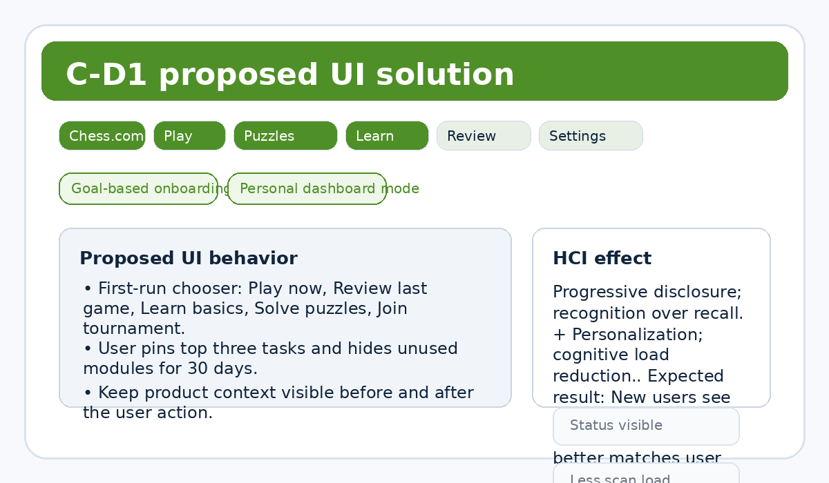  Illustrative redesign sketch, not captured live UI.
ID | Solution concept |  | How the UI fixes it | HCI principle | Expected result |  | Tradeoff
C-S1 | Goal-based onboarding home |  | First-run chooser: Play now, Review last game, Learn basics, Solve puzzles, Join tournament. | Progressive disclosure; recognition over recall. | New users see goals before feature taxonomy. |  | Adds onboarding state management.
C-S2 | Personal dashboard mode |  | User pins top three tasks and hides unused modules for 30 days. | Personalization; cognitive load reduction. | Homepage better matches user intent. |  | May hide growth paths if poorly explained.

C-D2 - Chess.com drawback and solution card
Problem  Game Review and Analysis expose dense charts, lines, classifications, toggles, and labels before novices know what matters. |  | Persona  C-P1 / C-P3 |  | Context  Post-loss review on laptop or desktop. |  | HCI cause  Cognitive load; external cognition.
Evidence  Source-only [15][16][17] |  | Severity  High |  | Priority  High |  | Effort  Low
Observed evidence or source status |  |  |  | Low-fidelity UI proposal
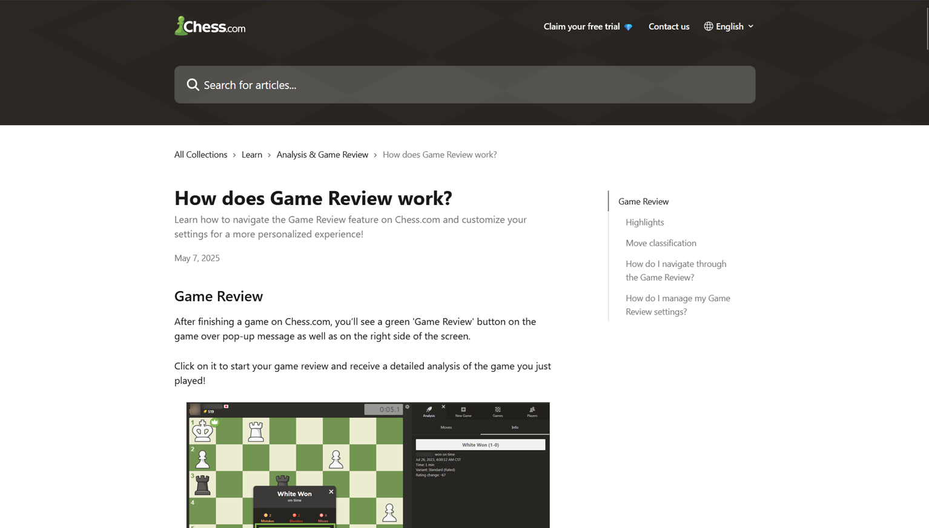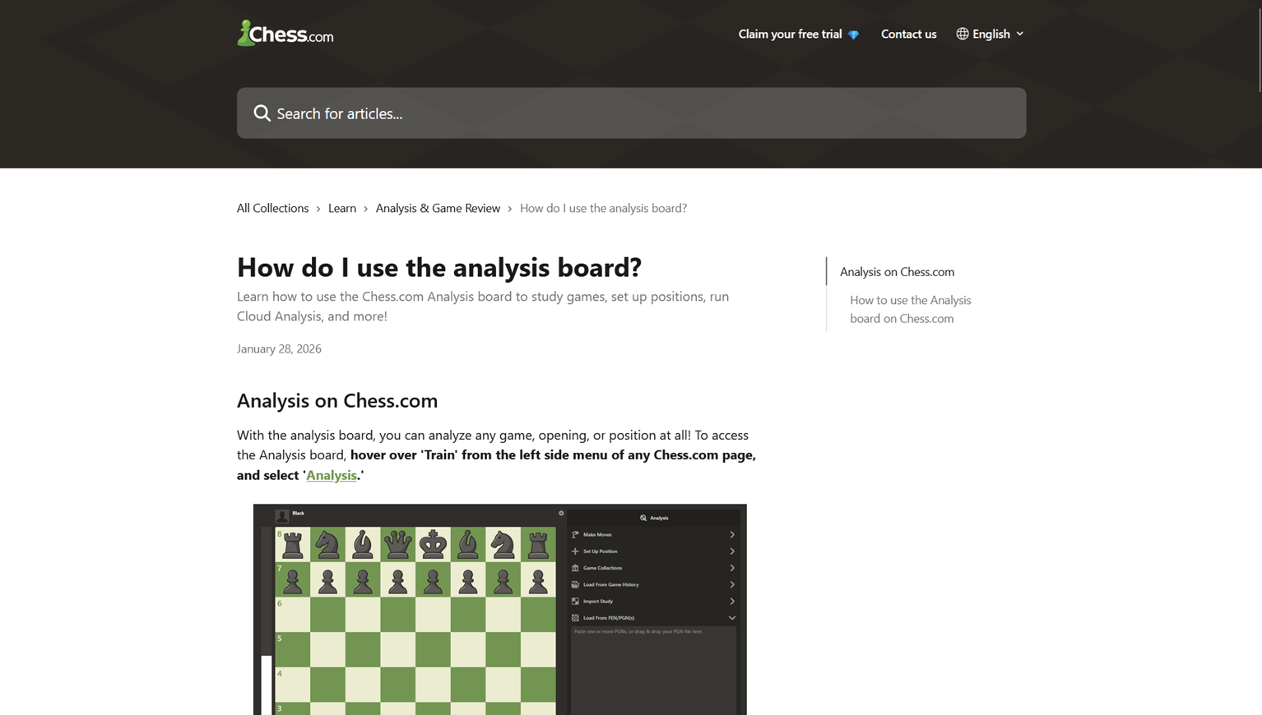 |  |  |  | 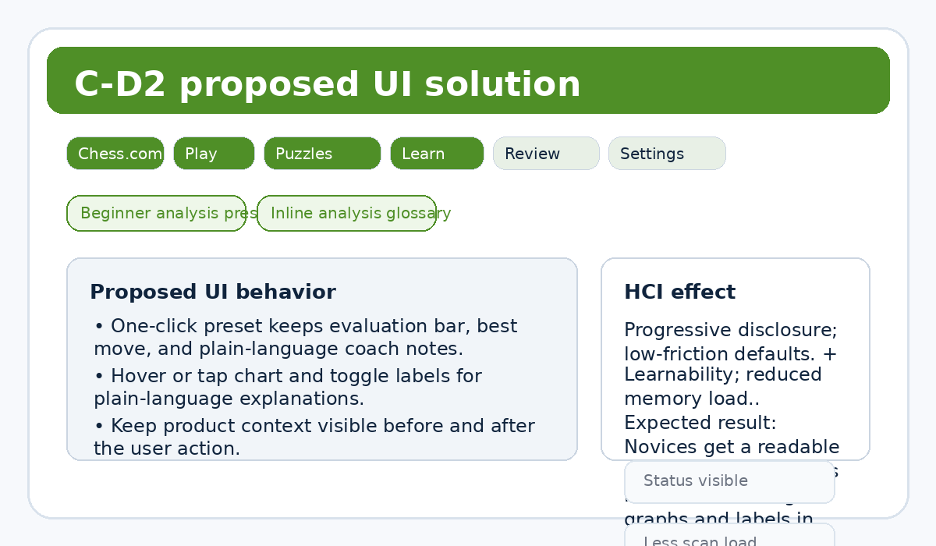  Illustrative redesign sketch, not captured live UI.
ID | Solution concept |  | How the UI fixes it | HCI principle | Expected result |  | Tradeoff
C-S3 | Beginner analysis preset |  | One-click preset keeps evaluation bar, best move, and plain-language coach notes. | Progressive disclosure; low-friction defaults. | Novices get a readable analysis surface. |  | Advanced controls become one step deeper.
C-S4 | Inline analysis glossary |  | Hover or tap chart and toggle labels for plain-language explanations. | Learnability; reduced memory load. | Users learn the meaning of graphs and labels in place. |  | Adds copy maintenance and localization work.

C-D3 - Chess.com drawback and solution card
Problem  Lesson, puzzle, and review limits can appear after attention is invested and interrupt learning momentum. |  | Persona  C-P1 / C-P3 |  | Context  Beginner learning path after a loss. |  | HCI cause  Expectation setting; continuity; visibility of access state.
Evidence  Source-only [19] |  | Severity  Medium |  | Priority  Medium |  | Effort  Low
Observed evidence or source status |  |  |  | Low-fidelity UI proposal
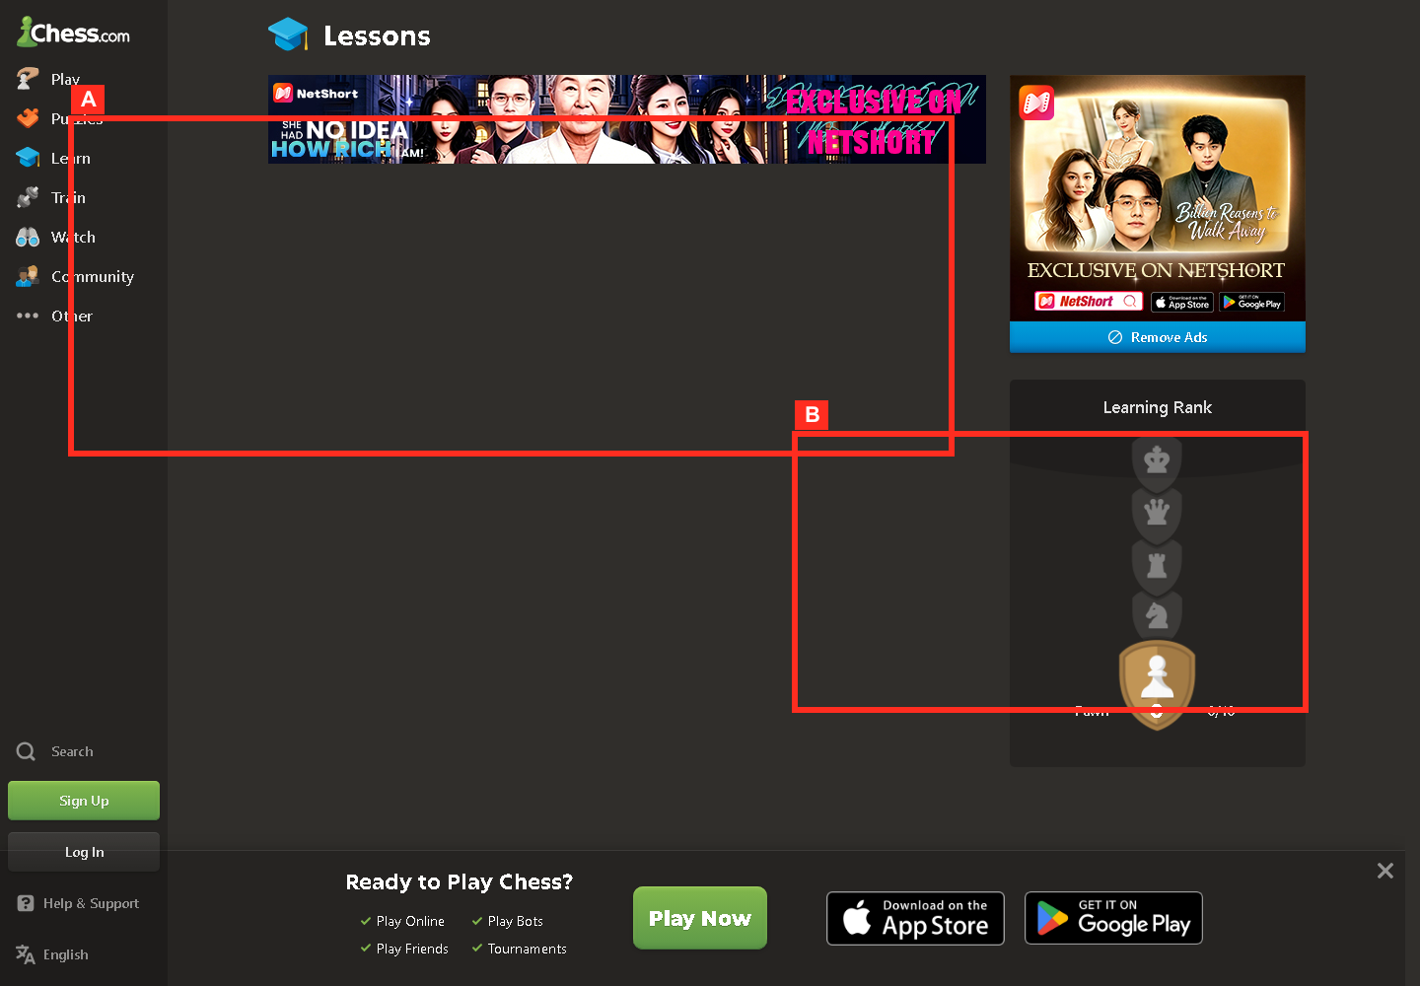  Evidence: C-05_chess_learn_page.png (Source-only [19]) |  |  |  | 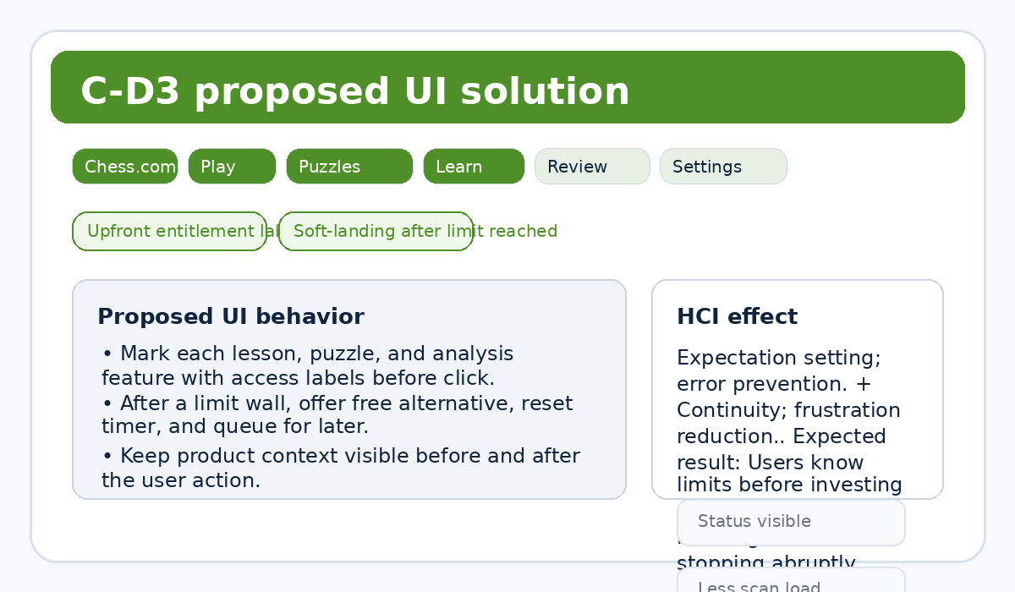  Illustrative redesign sketch, not captured live UI.
ID | Solution concept |  | How the UI fixes it | HCI principle | Expected result |  | Tradeoff
C-S5 | Upfront entitlement labels |  | Mark each lesson, puzzle, and analysis feature with access labels before click. | Expectation setting; error prevention. | Users know limits before investing attention. |  | Access labels may add visual noise.
C-S6 | Soft-landing after limit reached |  | After a limit wall, offer free alternative, reset timer, and queue for later. | Continuity; frustration reduction. | Users keep learning instead of stopping abruptly. |  | May reduce upgrade pressure.

C-D4 - Chess.com drawback and solution card
Problem  A legal queued premove may execute after an unexpected reply and create a blunder. |  | Persona  C-P2 |  | Context  Blitz or bullet under clock pressure. |  | HCI cause  Speed-accuracy tradeoff; Error prevention; recoverability.
Evidence  Source-only [12] |  | Severity  High |  | Priority  High |  | Effort  Medium
Observed evidence or source status |  |  |  | Low-fidelity UI proposal
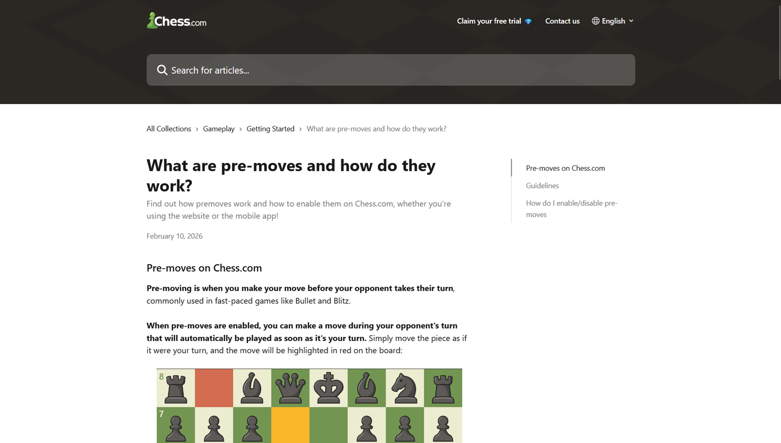 |  |  |  | 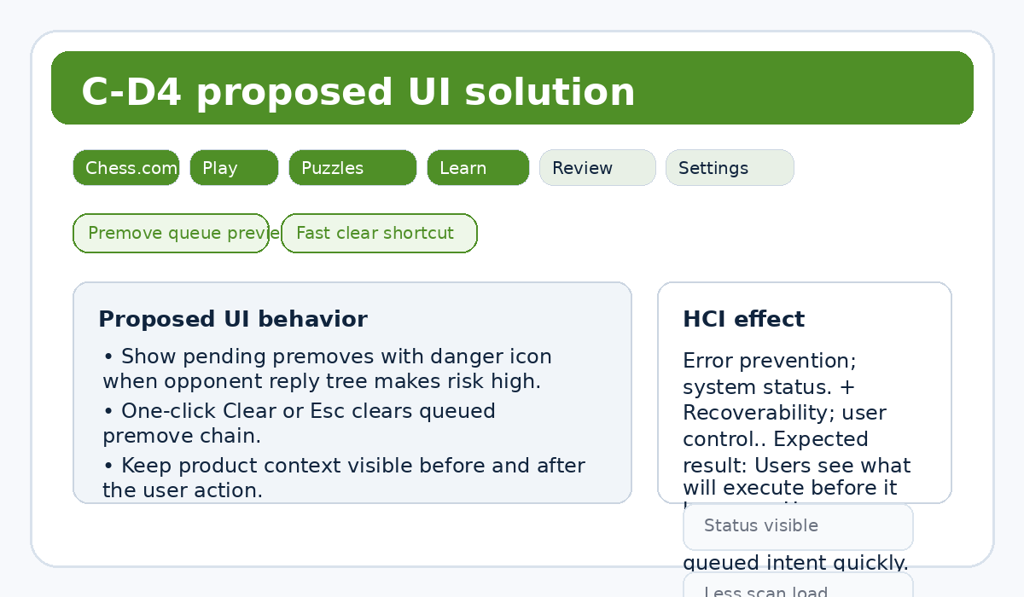  Illustrative redesign sketch, not captured live UI.
ID | Solution concept |  | How the UI fixes it | HCI principle | Expected result |  | Tradeoff
C-S7 | Premove queue preview |  | Show pending premoves with danger icon when opponent reply tree makes risk high. | Error prevention; system status. | Users see what will execute before it happens. |  | Risk estimate can be imperfect.
C-S8 | Fast clear shortcut |  | One-click Clear or Esc clears queued premove chain. | Recoverability; user control. | Users recover from risky queued intent quickly. |  | Adds one more in-game control.

C-D5 - Chess.com drawback and solution card
Problem  Focus Mode is hard to discover because related controls appear on hover near the board boundary. |  | Persona  C-P2 / C-P3 |  | Context  Serious-game setup on desktop. |  | HCI cause  Discoverability; hidden controls; contextual help.
Evidence  Source-only [13][14] |  | Severity  Medium |  | Priority  Medium |  | Effort  Low
Observed evidence or source status |  |  |  | Low-fidelity UI proposal
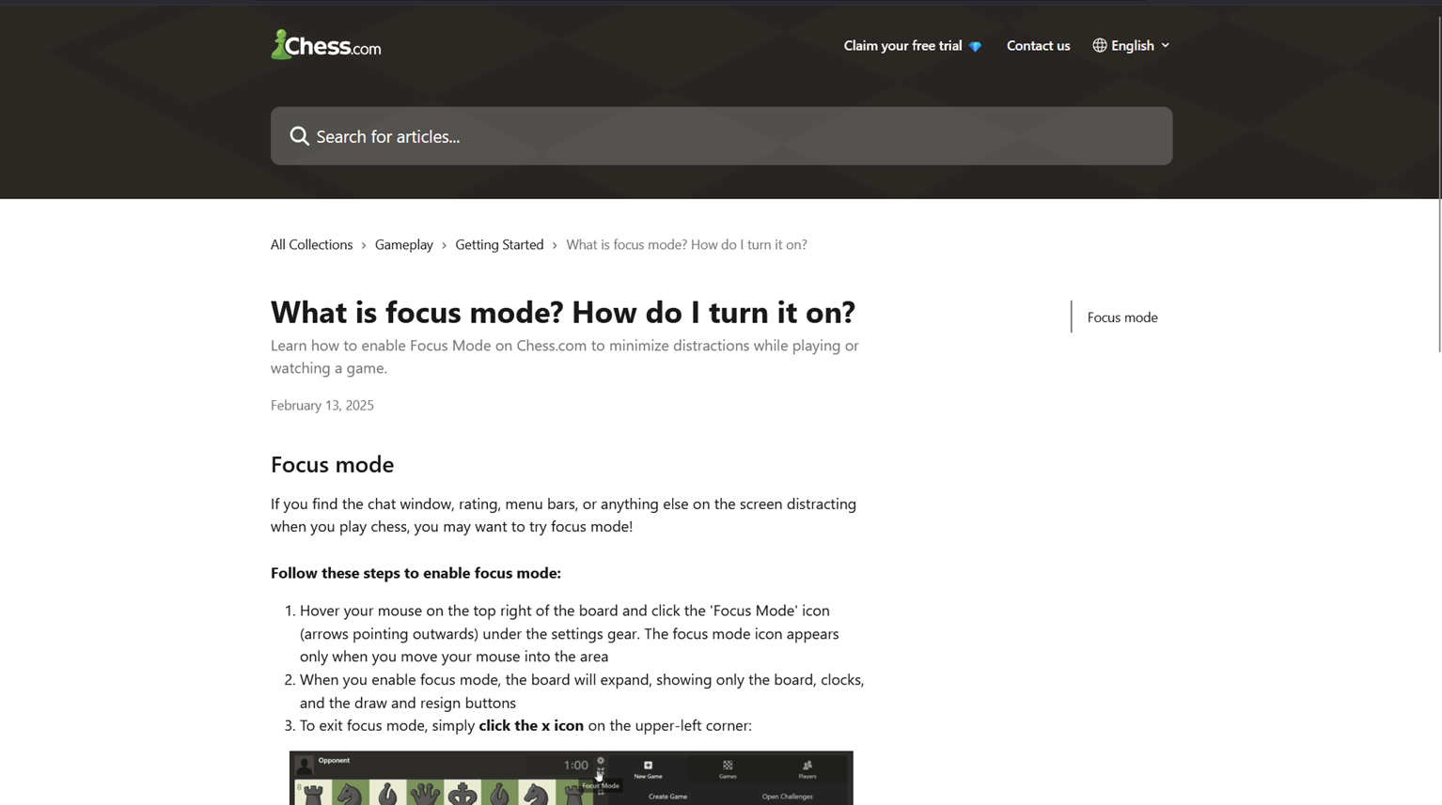 |  |  |  | 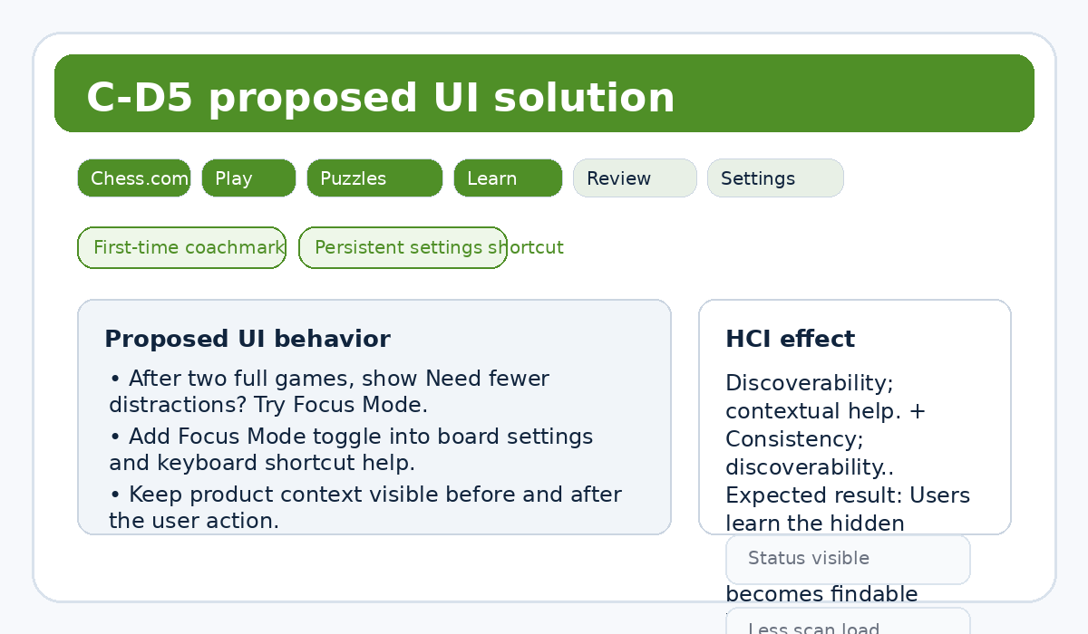  Illustrative redesign sketch, not captured live UI.
ID | Solution concept |  | How the UI fixes it | HCI principle | Expected result |  | Tradeoff
C-S9 | First-time coachmark |  | After two full games, show Need fewer distractions? Try Focus Mode. | Discoverability; contextual help. | Users learn the hidden control when it is relevant. |  | Coachmarks can annoy expert users.
C-S10 | Persistent settings shortcut |  | Add Focus Mode toggle into board settings and keyboard shortcut help. | Consistency; discoverability. | Focus Mode becomes findable without hover discovery. |  | Settings panel grows slightly.

Prioritized rollout plan
Quick wins
ID | Concept | Why first
F-S2 | Audience intent switcher | High priority with Low effort. Can be tested without changing the full product architecture.
F-S3 | Handoff explainer card | High priority with Low effort. Can be tested without changing the full product architecture.
C-S3 | Beginner analysis preset | High priority with Low effort. Can be tested without changing the full product architecture.
C-S5 | Upfront entitlement labels | High priority with Low effort. Can be tested without changing the full product architecture.
F-S9 | Utility rail on story pages | Medium priority with Low effort. Can be tested without changing the full product architecture.
F-S10 | Embedded action chips in articles | Medium priority with Low effort. Can be tested without changing the full product architecture.
C-S8 | Fast clear shortcut | Medium priority with Low effort. Can be tested without changing the full product architecture.
C-S9 | First-time coachmark | Medium priority with Low effort. Can be tested without changing the full product architecture.
C-S10 | Persistent settings shortcut | Medium priority with Low effort. Can be tested without changing the full product architecture.
Deeper redesigns
ID | Concept | Why deeper
F-S1 | Task-first global nav | Requires cross-page, data, personalization, or cross-property coordination.
F-S4 | Shared breadcrumb and visual bridge | Requires cross-page, data, personalization, or cross-property coordination.
F-S5 | Filter-first rail controls | Requires cross-page, data, personalization, or cross-property coordination.
F-S6 | Compact scan mode | Requires cross-page, data, personalization, or cross-property coordination.
F-S7 | Ticket status dashboard | Requires cross-page, data, personalization, or cross-property coordination.
F-S8 | Official availability alerts | Requires cross-page, data, personalization, or cross-property coordination.
C-S1 | Goal-based onboarding home | Requires cross-page, data, personalization, or cross-property coordination.
C-S2 | Personal dashboard mode | Requires cross-page, data, personalization, or cross-property coordination.
C-S4 | Inline analysis glossary | Requires cross-page, data, personalization, or cross-property coordination.
C-S6 | Soft-landing after limit reached | Requires cross-page, data, personalization, or cross-property coordination.
C-S7 | Premove queue preview | Requires cross-page, data, personalization, or cross-property coordination.
Rollout plan
Sprint 1 implements quick wins, tests wording and UI placement, and validates with the personas most affected by each drawback. Sprint 2 handles task-first navigation, ticket status, FIFA+ filters, personalized Chess.com home, glossary behavior, and premove queue preview. QA checks that every drawback from ProductResearch still maps to exactly two solutions.
Compact solution detail matrix
ID | Drawback | Concept | Detailed UI behavior | HCI mapping | Expected effect | Tradeoff | Priority | Effort
F-S1 | F-D1 | Task-first global nav | Keep Match Centre, News, Rankings, Tickets, Watch at top level; move Store, Collect, and Rewards into More FIFA. | Recognition over recall; Cognitive load reduction. | Fewer property jumps for common tasks. | Store and collectibles receive less top-level exposure. | High | Medium
F-S2 | F-D1 | Audience intent switcher | Add five quick-intent chips under the hero: Scores, News, Rankings, Tickets, Watch. | Feedforward; efficient entry. | Users choose by intent before reading navigation labels. | One more row competes for above-fold attention. | High | Low
F-S3 | F-D2 | Handoff explainer card | Before leaving FIFA.com, show You are opening FIFA+ powered by DAZN with destination benefits and sign-in expectation. | Visibility of system status; trust. | Users understand why branding and login state change. | Adds one step for repeat viewers. | High | Low
F-S4 | F-D2 | Shared breadcrumb and visual bridge | Add persistent Back to FIFA.com strip and tournament breadcrumb on FIFA+. | Continuity; orientation. | Users retain orientation across the watch boundary. | Needs cross-property coordination. | Medium | Medium
F-S5 | F-D3 | Filter-first rail controls | Provide filters for Live, Highlights, Documentaries, Competition, and Duration above rails. | Visual filtering; reduced scan cost. | Users narrow a large content surface faster. | Filter accuracy depends on metadata quality. | High | Medium
F-S6 | F-D3 | Compact scan mode | Collapse nonmatching rails into section labels until expanded. | Progressive disclosure; visual economy. | Lower vertical scanning burden. | Some content feels less discoverable. | Medium | Medium
F-S7 | F-D4 | Ticket status dashboard | Show Official sale, Resale open, Waiting room, Coming soon, and Latest update time by tournament. | Visibility of system status; planning support. | Users know whether to act now or wait. | Requires reliable status data and governance. | High | Medium
F-S8 | F-D4 | Official availability alerts | Offer email and browser alerts by tournament and market, confirmed by receipt. | Memory load reduction; trust. | Users stop manually rechecking availability. | Notification fatigue and opt-in compliance. | Medium | Medium
F-S9 | F-D5 | Utility rail on story pages | Add right rail or sticky side sheet for Scores today, Rankings latest, Tickets official source, Watch now. | Task continuity; reduced jumping. | Story readers can branch into utilitarian tasks in context. | May distract from article reading. | Medium | Low
F-S10 | F-D5 | Embedded action chips in articles | Add context chips in article header: Open Match Centre, View Tickets, Watch on FIFA+. | Contextual navigation; information scent. | Users can act from the article without searching navigation again. | Requires article metadata rules. | Medium | Low
C-S1 | C-D1 | Goal-based onboarding home | First-run chooser: Play now, Review last game, Learn basics, Solve puzzles, Join tournament. | Progressive disclosure; recognition over recall. | New users see goals before feature taxonomy. | Adds onboarding state management. | High | Medium
C-S2 | C-D1 | Personal dashboard mode | User pins top three tasks and hides unused modules for 30 days. | Personalization; cognitive load reduction. | Homepage better matches user intent. | May hide growth paths if poorly explained. | Medium | Medium
C-S3 | C-D2 | Beginner analysis preset | One-click preset keeps evaluation bar, best move, and plain-language coach notes. | Progressive disclosure; low-friction defaults. | Novices get a readable analysis surface. | Advanced controls become one step deeper. | High | Low
C-S4 | C-D2 | Inline analysis glossary | Hover or tap chart and toggle labels for plain-language explanations. | Learnability; reduced memory load. | Users learn the meaning of graphs and labels in place. | Adds copy maintenance and localization work. | Medium | Medium
C-S5 | C-D3 | Upfront entitlement labels | Mark each lesson, puzzle, and analysis feature with access labels before click. | Expectation setting; error prevention. | Users know limits before investing attention. | Access labels may add visual noise. | High | Low
C-S6 | C-D3 | Soft-landing after limit reached | After a limit wall, offer free alternative, reset timer, and queue for later. | Continuity; frustration reduction. | Users keep learning instead of stopping abruptly. | May reduce upgrade pressure. | Medium | Medium
C-S7 | C-D4 | Premove queue preview | Show pending premoves with danger icon when opponent reply tree makes risk high. | Error prevention; system status. | Users see what will execute before it happens. | Risk estimate can be imperfect. | High | Medium
C-S8 | C-D4 | Fast clear shortcut | One-click Clear or Esc clears queued premove chain. | Recoverability; user control. | Users recover from risky queued intent quickly. | Adds one more in-game control. | Medium | Low
C-S9 | C-D5 | First-time coachmark | After two full games, show Need fewer distractions? Try Focus Mode. | Discoverability; contextual help. | Users learn the hidden control when it is relevant. | Coachmarks can annoy expert users. | Medium | Low
C-S10 | C-D5 | Persistent settings shortcut | Add Focus Mode toggle into board settings and keyboard shortcut help. | Consistency; discoverability. | Focus Mode becomes findable without hover discovery. | Settings panel grows slightly. | Medium | Low
References
[1] Inside FIFA. Official FIFA news and navigation. https://inside.fifa.com/. Accessed 2026-06-10.
[2] All stories and topics. Official FIFA topic index. https://inside.fifa.com/all-stories. Accessed 2026-06-10.
[3] FIFA World Cup 2026 Blog. Official FIFA tournament story hub. https://inside.fifa.com/blogs/fwc-2026. Accessed 2026-06-10.
[4] FIFA World Cup 26 Ticketing Programme launches this September. Official FIFA media release. https://inside.fifa.com/tournament-organisation/commercial/media-releases/world-cup-26-ticketing-programme-launch-september. Accessed 2026-06-10.
[5] FIFA World Cup 2026 Last-Minute Sales Phase. Official FIFA media release. https://inside.fifa.com/media-releases/last-minute-ticket-sales-phase-fifa-world-cup-2026. Accessed 2026-06-10.
[6] Watch FIFA+ Live Stream Online. Official FIFA+ watch destination. https://www.plus.fifa.com/. Accessed 2026-06-10.
[7] Match Centre. Official FIFA fixtures and results page. https://www.fifa.com/en/match-centre. Accessed 2026-06-10.
[9] Tickets and Hospitality. Official FIFA ticket entry point. https://www.fifa.com/en/tickets. Accessed 2026-06-10.
[10] Chess.com homepage. https://www.chess.com/. Accessed 2026-06-10.
[11] How do I start a game on Chess.com? Official Chess.com help. https://support.chess.com/en/articles/8609779-how-do-i-start-a-game-on-chess-com. Accessed 2026-06-10.
[12] What are pre-moves and how do they work? Official Chess.com help. https://support.chess.com/en/articles/8562432-what-are-pre-moves-and-how-do-they-work. Accessed 2026-06-10.
[13] What is Focus Mode? How do I turn it on? Official Chess.com help. https://support.chess.com/en/articles/8588088-what-is-focus-mode-how-do-i-turn-it-on. Accessed 2026-06-10.
[14] How do I change my board size? Official Chess.com help. https://support.chess.com/en/articles/8609533-how-do-i-change-my-board-size. Accessed 2026-06-10.
[15] How does Game Review work? Official Chess.com help. https://support.chess.com/en/articles/8584089-how-does-game-review-work. Accessed 2026-06-10.
[17] How do I use the Analysis Board? Official Chess.com help. https://support.chess.com/en/articles/8583825-how-do-i-use-the-analysis-board. Accessed 2026-06-10.
[19] How do Lessons work on Chess.com? Official Chess.com help. https://support.chess.com/en/articles/8609703-how-do-lessons-work-on-chess-com. Accessed 2026-06-10.
[20] Chess Study Plans for All Levels. Official Chess.com article. https://www.chess.com/article/view/study-plan-directory. Accessed 2026-06-10.

